Ideation Phase
Brainstorm & Idea Prioritization Template
Date | 28 October 2026
Team ID | To Be Confirmed
Project Name | HotelPro – Hotel Management System
Maximum Marks | 4 Marks
Document Status | Draft v1.0 – prepared from the stated HotelPro requirements. No HotelPro source code has been provided or verified, so all features are marked Planned.

1. Brainstorm & Idea Prioritization Template
Brainstorming provides a free and open environment that encourages everyone within a team to participate in the creative thinking process that leads to problem solving. Volume is prioritised over value at first; ideas are then grouped, scored and selected. This document records the ideas generated for HotelPro and how they were prioritised.
Team members, session date and participant names are To Be Confirmed. Impact and effort scores are the project team's initial estimates for planning and should be revisited after stakeholder feedback.

Step 1: Team Gathering, Collaboration and Select the Problem Statement
Selected problem statement: How might we help hotel guests book and pay for rooms with confidence, while giving staff, managers and administrators one reliable system to run daily hotel operations? (Derived from PS-1 to PS-6 in the “Define the Problem Statements” document.)
Table 1: Session details
Item | Details
Facilitator / Team members | To Be Confirmed
Session date and mode | To Be Confirmed
Problem statements considered | PS-1 to PS-6
Method | Silent idea writing, grouping, impact/effort scoring

Step 2: Brainstorm, Idea Listing and Grouping
Table 2: Idea groups
Group | Ideas
A. Guest experience | I1 Room search with date availability; I2 Secure online booking and payment; I9 Reviews and ratings; I4 Email and in-app notifications
B. Hotel operations | I5 Digital check-in / check-out; I6 Housekeeping task board; I10 Guest service requests
C. Management and revenue | I7 Seasonal pricing rules; I8 Occupancy and revenue analytics; I3 Role-based dashboards
D. Security and governance | I11 Audit logs and security monitoring
E. Future / innovation | I12 AI chatbot concierge; I13 Native mobile app; I14 Loyalty and rewards programme; I15 IoT smart-room controls

Step 3: Idea Prioritization
Each idea was scored for expected impact on users (1–10) and estimated effort (1–10). Ideas with high impact and manageable effort form the Minimum Viable Product (MVP). Ideas that support operations and revenue follow in Phase 2. Ideas with high effort or low immediate impact are kept as future enhancements.
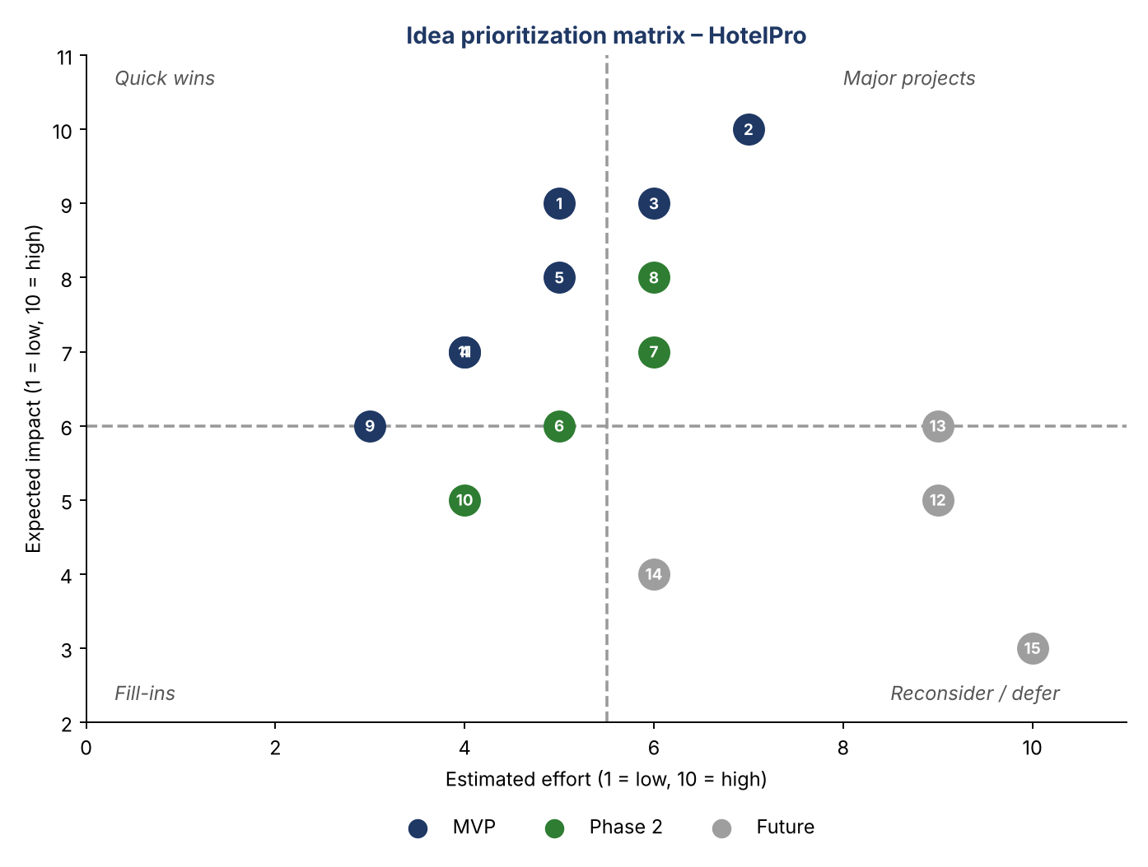
Figure 1: Idea prioritization matrix (Impact vs Effort)
Table 3: Idea scoring and classification
ID | Idea | Impact | Effort | Priority Class | Related Requirements
I1 | Room search with date availability | 9 | 5 | MVP | FR-G4
I2 | Secure online booking and payment | 10 | 7 | MVP | FR-G5, FR-G6
I3 | Role-based dashboards | 9 | 6 | MVP | FR-X1
I4 | Email and in-app notifications | 7 | 4 | MVP | FR-G10
I5 | Digital check-in / check-out | 8 | 5 | MVP | FR-S1
I9 | Reviews and ratings | 6 | 3 | MVP | FR-G9
I11 | Audit logs and security monitoring | 7 | 4 | MVP | FR-X4, FR-A5
I6 | Housekeeping task board | 6 | 5 | Phase 2 | FR-S4
I7 | Seasonal pricing rules | 7 | 6 | Phase 2 | FR-M2
I8 | Occupancy and revenue analytics | 8 | 6 | Phase 2 | FR-M6, FR-A4
I10 | Guest service requests | 5 | 4 | Phase 2 | FR-S5
I12 | AI chatbot concierge | 5 | 9 | Future | Not in current scope
I13 | Native mobile app | 6 | 9 | Future | Not in current scope
I14 | Loyalty and rewards programme | 4 | 6 | Future | Not in current scope
I15 | IoT smart-room controls | 3 | 10 | Future | Not in current scope

Prioritization Outcome
- MVP: I1, I2, I3, I4, I5, I9, I11 – authentication, search, booking, payment, notifications, check-in/out, reviews and audit logging.
- Phase 2: I6, I7, I8, I10 – housekeeping, seasonal pricing, analytics and service requests.
- Future: I12–I15 – recorded for later evaluation; not planned for the current release.

References
- Brainstorm and Idea Prioritization (Mural) – https://www.mural.co/templates/brainstorm-and-idea-prioritization

